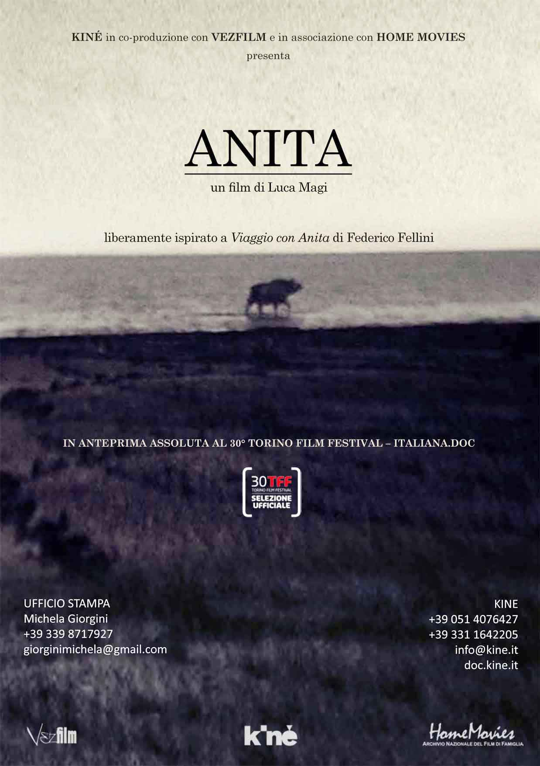

ANITA
A film by Luca Magi
Freely inspired by Federico Fellini and Tullio Pinelli’s film treatment A Journey with Anita
Italy 2012, colour/black and white, HD/8mm/super8, 55 minutes.

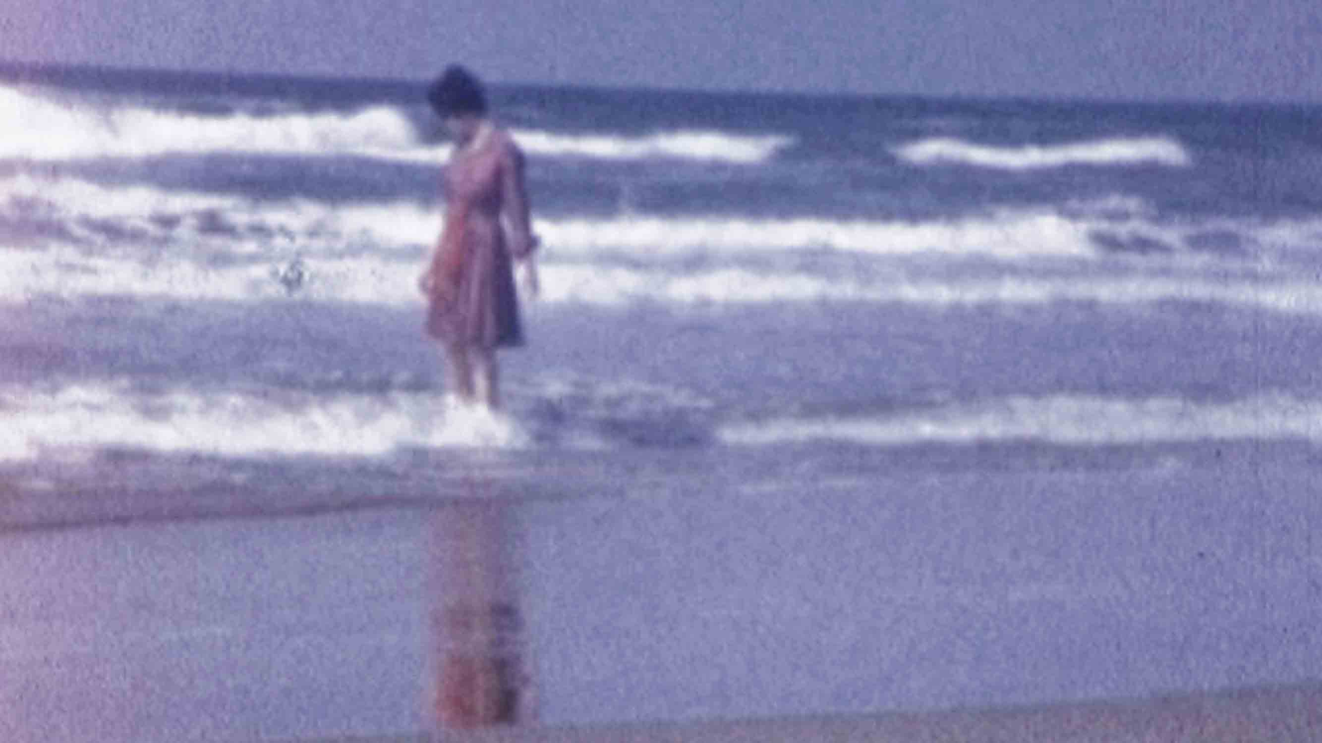

Director Luca Magi
Screenplay Antonio Bigini
Producer Alessandro Carroli
Cinematography Claudio Giapponesi, Luca Magi
Editing Claudio Giapponesi
Sound Massimo Carozzi
Voice Emidio Clementi
Production Kiné (IT) / Vezfilm (UK)
In association with Home Movies – Archivio Nazionale del Film di Famiglia
With the support of Fondazione Del Monte / Comune di Fano
Website doc.kine.it
Press office Michela Giorgini
+39 339 8717927
giorginimichela@gmail.com

ANITA

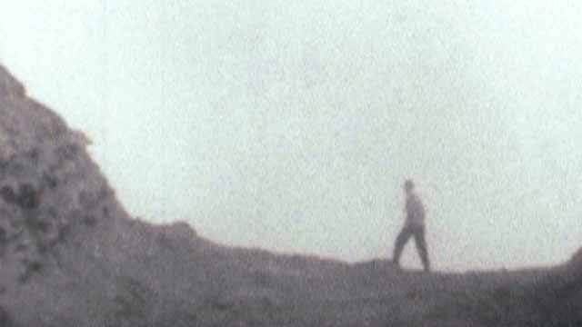

Synopsis
Inspired by A Journey with Anita, a treatment Fellini never turned into a film, the director leads us through a secret Italy, far from beaten paths. The film follows the tracks of two lovers, Guido and Anita, in their journey to reach Guido's dying father. The result is a film with an extraordinary visual impact, composed of encounters with timeless characters found along the two lovers’ route. A sophisticated first work that owns its charm to its original use of 8mm and Super-8 archive footage.

A Journey with Anita
A Journey with Anita is a script written by Federico Fellini and Tullio Pinelli in 1957. Pier Paolo Pasolini also contributed to it. The film script is unpublished in Italy – the only available edition is American (Moraldo in the city and A Journey with Anita, edited by J.C. Stubbs, University of Illinois Press, 1983) – and is one of three road movies Fellini never shot, along with Il viaggio di Mastorna and Trip to Tulun. In 1989, in an interview for the magazine Civiltà Cattolica, Fellini declared: “The best script I ever wrote, but did not film, is A Journey with Anita. I sold it many years later, a bit shamefully, to Grimaldi, who had it produced by Monicelli, but it has become a totally different thing. My biggest regret is that I never made this film”.

ANITA

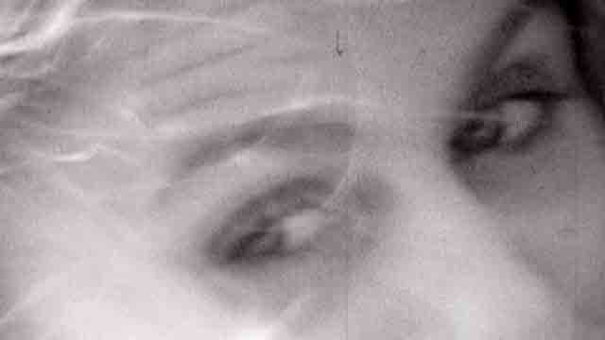

Director’s statement
A Journey with Anita is the most intimate film Fellini has ever written. It’s no accident, I think, that he ended up not making it: the subject was too tricky; he felt the need to free himself from it, even though he later regretted. It seems to me that among the many projects he did not realize, this is the most precious one, because it allows us to investigate Fellini's heart and thoughts.

Guido’s trip to his hometown is a journey towards his origins and his lost innocence. It is a theme Fellini developed in most of his films but here he wanted to achieve it through clear and strong symbolism. Completed after four years of intense work, Anita is a film made of encounters, in which the journey of the two lovers is intersected with the characters I filmed following Guido and Anita’s path today. Sometimes these intersections are narrative; sometimes it’s just a matter of themes (the fisherman, in the final episode, is a sort of Guido's double); sometimes it is both things, as in the episode of the Madonna del Parto.

As for the found footage, I also worked following a double track, narrative and symbolic. The amateur films I used evoke the journey of the two protagonists but also strengthen the symbolism that is present in the whole film.

The work on time has always been at the core of my artistic research. In Anita I was probably attracted by that challenge: trying to create a story belonging to the past, but that has never been told. A story that is fictional but also carries traces of reality. My whole creative effort was concentrated on the translation of this paradox, in the attempt of realizing a work that is able to combine art and documentary filmmaking.
Luca Magi
Luca Magi
Born in 1976. Graduated from the Accademia di Belle arti of Urbino, he works as a drawer, illustrator and visual artist. Anita is his first film.
ANITA

THE CREW

Emidio Clementi
Musician and writer, since 1980 he has been the lead singer of the band Massimo Volume, for which he also writes the lyrics. Among his books are L'ultimo dio, La notte del Pratello and La ragione delle mani.

Massimo Carozzi
Composer, musician and sound designer, he is one of the founders of the Zimmer Frei collective of artists, to which the Torino Film Fest dedicates a retrospective in 2012.

Antonio Bigini
Author and writter, he co-directed Formato ridotto (2012). He is also the author of the book Tonino Guerra wants to kill me.

Alessandro Carroli
Assistant producer for directors like Ermanno Olmi, Paolo Franchi and Giuseppe Bertolucci, since 2009 he is responsible for Kiné's documentary production.

Claudio Giapponesi
Editor and producer, he is among the founders of Kiné. He has been the editor of the film The Enemy Within (2009) and co-director and editor of Come un canto (2009) and Formato ridotto (2009).

PRODUCTION

Kiné
Exclusive partner of Home Movies – Italian National Amateur Film Archives, Kiné has produced several documentaries, some of which in co-production with ARTE France (Brèves histoires de l’amour qui dure) and Al Jazeera (The Enemy Within). Its last productions include J'attends une femme (2010) by Chiara Malta, Eden's Ark (2011) by Marcelo Felix and Formato ridotto (2012). doc.kine.it

Vezfilm
Created in London in 2010, it produces documentary films and crossmedia projects. Its first international co-production is My House Without Me by Magdalena Szymkow (2012), co-prodced with Wajda Studios (Poland). www.vezfilm.org

Home Movies – Italian National Amateur Film Archives
Home Movies collects amateur films (8mm, super 8, 9,5mm, 16mm) made all over Italy. Over the last years it has attracted many international productions, interested in its 9000 films and 3000 hours of footage. Among the recent Italian films that used footage from the archive are La Bocca del lupo (Pietro Marcello, 2009), Pasta Nera (Alessandro Piva, 2011), Italy: Love it or Leave it (Luca Ragazzi, Gustav Hofer, 2011) and Tutto parla di te (Alina Marazzi, 2012). www.homemovies.it

ANITA

INTERVIEW TO DIRECTOR LUCA MAGI

Tell us about the process of making the film, from the first idea to the finished product. What attracted you the most in this project?
After reading Tullio Kezich’s biography of Federico Fellini, Antonio Bigini (the author of the film) discovered the existence of a film treatment called A Journey with Anita. We travelled to the Federico Fellini foundation in Rimini, to look through the original text, still unpublished in Italy today. What fascinated us was the power of the story, the main character’s journey of initiation as he travels back to his hometown and his roots. It is also a universal story set in the landscapes of Central Italy, the same ones in which Antonio and I grew up. We then decided to visit the places described in the treatment and we discovered places in which time seems to have stopped, lands inhabited by people almost unaffected by the passing of time. These places and people we encountered seem to have a mysterious link with Fellini’s text, and this is exactly what the film is trying to narrate.
Both in Fellini's treatment and in Anita, the places visited in Italy by the two lovers are particularly meaningful and rich in charm. Can you tell us something about these extraordinary locations?
A Journey with Anita is a sort of Italian coast-to-coast made by two lovers across some of the most beautiful spots of central Italy: Civita di Bagnoregio, an abandoned village suspended on a valley of badlands; Monterchi, with its famous Madonna del Parto fresco painted by Piero della Francesca, a work that has already been narrated by directors like Zurlini (Indian Summer, 1972) and Tarkovskij (Nostalghia, 1983); the Furlo pass, a lunar landscape the Marche region; and the city of Fano, that in Fellini’s imagination represented the Rimini of his childhood. In Anita those places, rather than simple locations, are actual characters.
Luca, your previous works belong to the world of illustration and visual arts rather than film. What was the impulse to choose cinema as an expressive instrument?
It is obvious that my relation with the image and drawing has influenced my way of conceiving the film. Initially the story of Guido and Anita should have been told through animations. I had already prepared a storyboard. After having watched the private 8mm and Super 8 footage collected by the Home Movies association in Bologna I realized that using the archives rather than animation films would be more effective. I spent two months locked in the archives in Bologna, bearing the preparatory drawings in my mind and selecting amateur films. Even for the documentary part of the film, my approach was strongly influenced by these drawings.
How did you work on the images of Anita?
Anita is divided between the reality of meetings and the history of Guido and Anita, evoked through the amateur films. The meetings have been shot with a digital camera, then transferred on a 16-mm film and eventually re-digitalized in order to represent the timelessness of the universe I wanted to describe. The archives have been more or less treated like drawings, with clear contours and overexposures. I wanted to create images that look like indefinite visions rescued from oblivion.
Can you say something about the sound? In Anita it seems to be particularly important.
I do not conceive sound as a mere accompaniment to the image, but rather as an extension of it. Music and sound are a single body. I needed sounds that could create a timeless atmosphere and “draw the light”, infusing it with the emotional range necessary to express the idea of the film. In the effort to do so Massimo Carozzi, the author of the sound and the music, had a crucial role.

